Modeling Projectile Motion Project

Instructions: You MUST show all of your work and explain each algebraic step in words. Use the built-in Equation Editor (Insert Equation) tool for mathematical expressions. If you use Excel to support any calculations and/or as a graphical tool, you must submit the companion Excel file (please save the file under the same name).

Modeling the Projectile Motion of a Soccer Ball
(Adapted from Lasode, Popoola & Olaleye, 2009)
Invented by the English but perfected by the Brazilians, the Jogo Bonito (The Best Brazilian Goals Ever) has reached every corner of the planet culturally and scientifically, and mathematics is no stranger to the game. The professional games held by FIFA are played in a stadium approximately 110 meters long and 90 meters wide. The projectile motion of the ball is usually affected by drag, which is a complicated function of the projectile velocity relative to air, based on experimental data.

PART I: Motion in the Absence of Drag. The equations of the ball's motion in the absence of drag are:
Figure 1: Soccer Field Dimensions (Metric units) (Source: SportsCourtDimensions.com.)

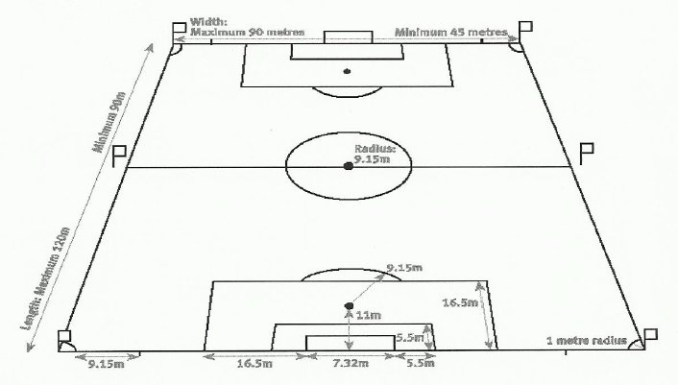

Where the gravitational acceleration g = 9.8 m/s² is constant and θ is in radians. Answer the following questions:

- Find y as a function of x.

- Use the function found in (1) to find the distance traveled by a ball struck with a speed of 30 m/s at an angle of 45º.

PART II: Motion with Drag. The equations of the ball's motion in the presence of drag are given by:

Where the gravitational acceleration g = 9.8 m/s² is constant and θ is in radians. Please answer the following questions:

- Find y as a function of x.

- Use the function found in (1) and find the distance traveled by a ball struck with a speed of 30 m/s at an angle of 45º.

PART III: O gol que ... On March, 06 1970, the world experienced one of the greatest goal kicks of all times during the Brazil vs. Czechoslovakia game. The great Pele shot the ball 5 meters before the midfield line and almost scored, and Brazilian physicists made a mathematical analysis of the shot (O gol que Pelé não fez). Based on the information given in the video and using some assumptions, the following information can be concluded: Vo = 29.167 m/s, θ = 24.212º, and k = 0.2976. Please answer the following questions:

- Use Microsoft Excel to graph the trajectory of the ball with and without drag using a [0, 70] by [0, 10] window. Please place the horizontal distance traveled on the x-axis and the vertical distance traveled on the y-axis.

- Based on your graph, was there air resistance present during the shot? Elaborate.

